Task 1: Selecting Your Client and Planning Your Website Design
Name: Draven Chen
Date: 06/12/2026
Overview
Select a client for your project. Build wireframes for four webpages, and select an appropriate color palette, logo, font color, and typography. Provide an analysis of your design choices.

Instructions
Provide your responses in the following table.

Client’s Name
Hint: What is the full business name of the client? Select a client from the provided clients list in the Client Scenario and Criteria.
Book Haven Bookstore

Build eight wireframes for the website and include the links to be able to access throughout the rest of the Touchstone tasks:
- The mobile wireframe link includes the Homepage, Gallery page, About Us page, and custom page.
- The desktop wireframe link includes the Homepage, Gallery page, About Us page, and custom page.

Wireframes should
- be organized to demonstrate a clear layout and should not be confusing;
- not include color;
- include some labels to indicate what each box or section represents;
- have a consistent header section, footer section, and navigation menu for all pages; and
- include, in the main sections of each page, appropriate elements, image placeholders, button placeholders, and paragraph and header placeholders (lorem ipsum or filler text is not required).

Mobile Wireframes
Homepage
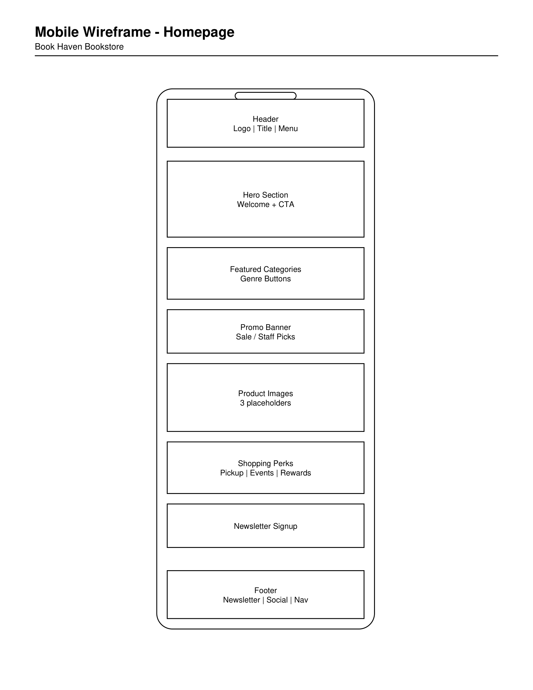
Gallery Page
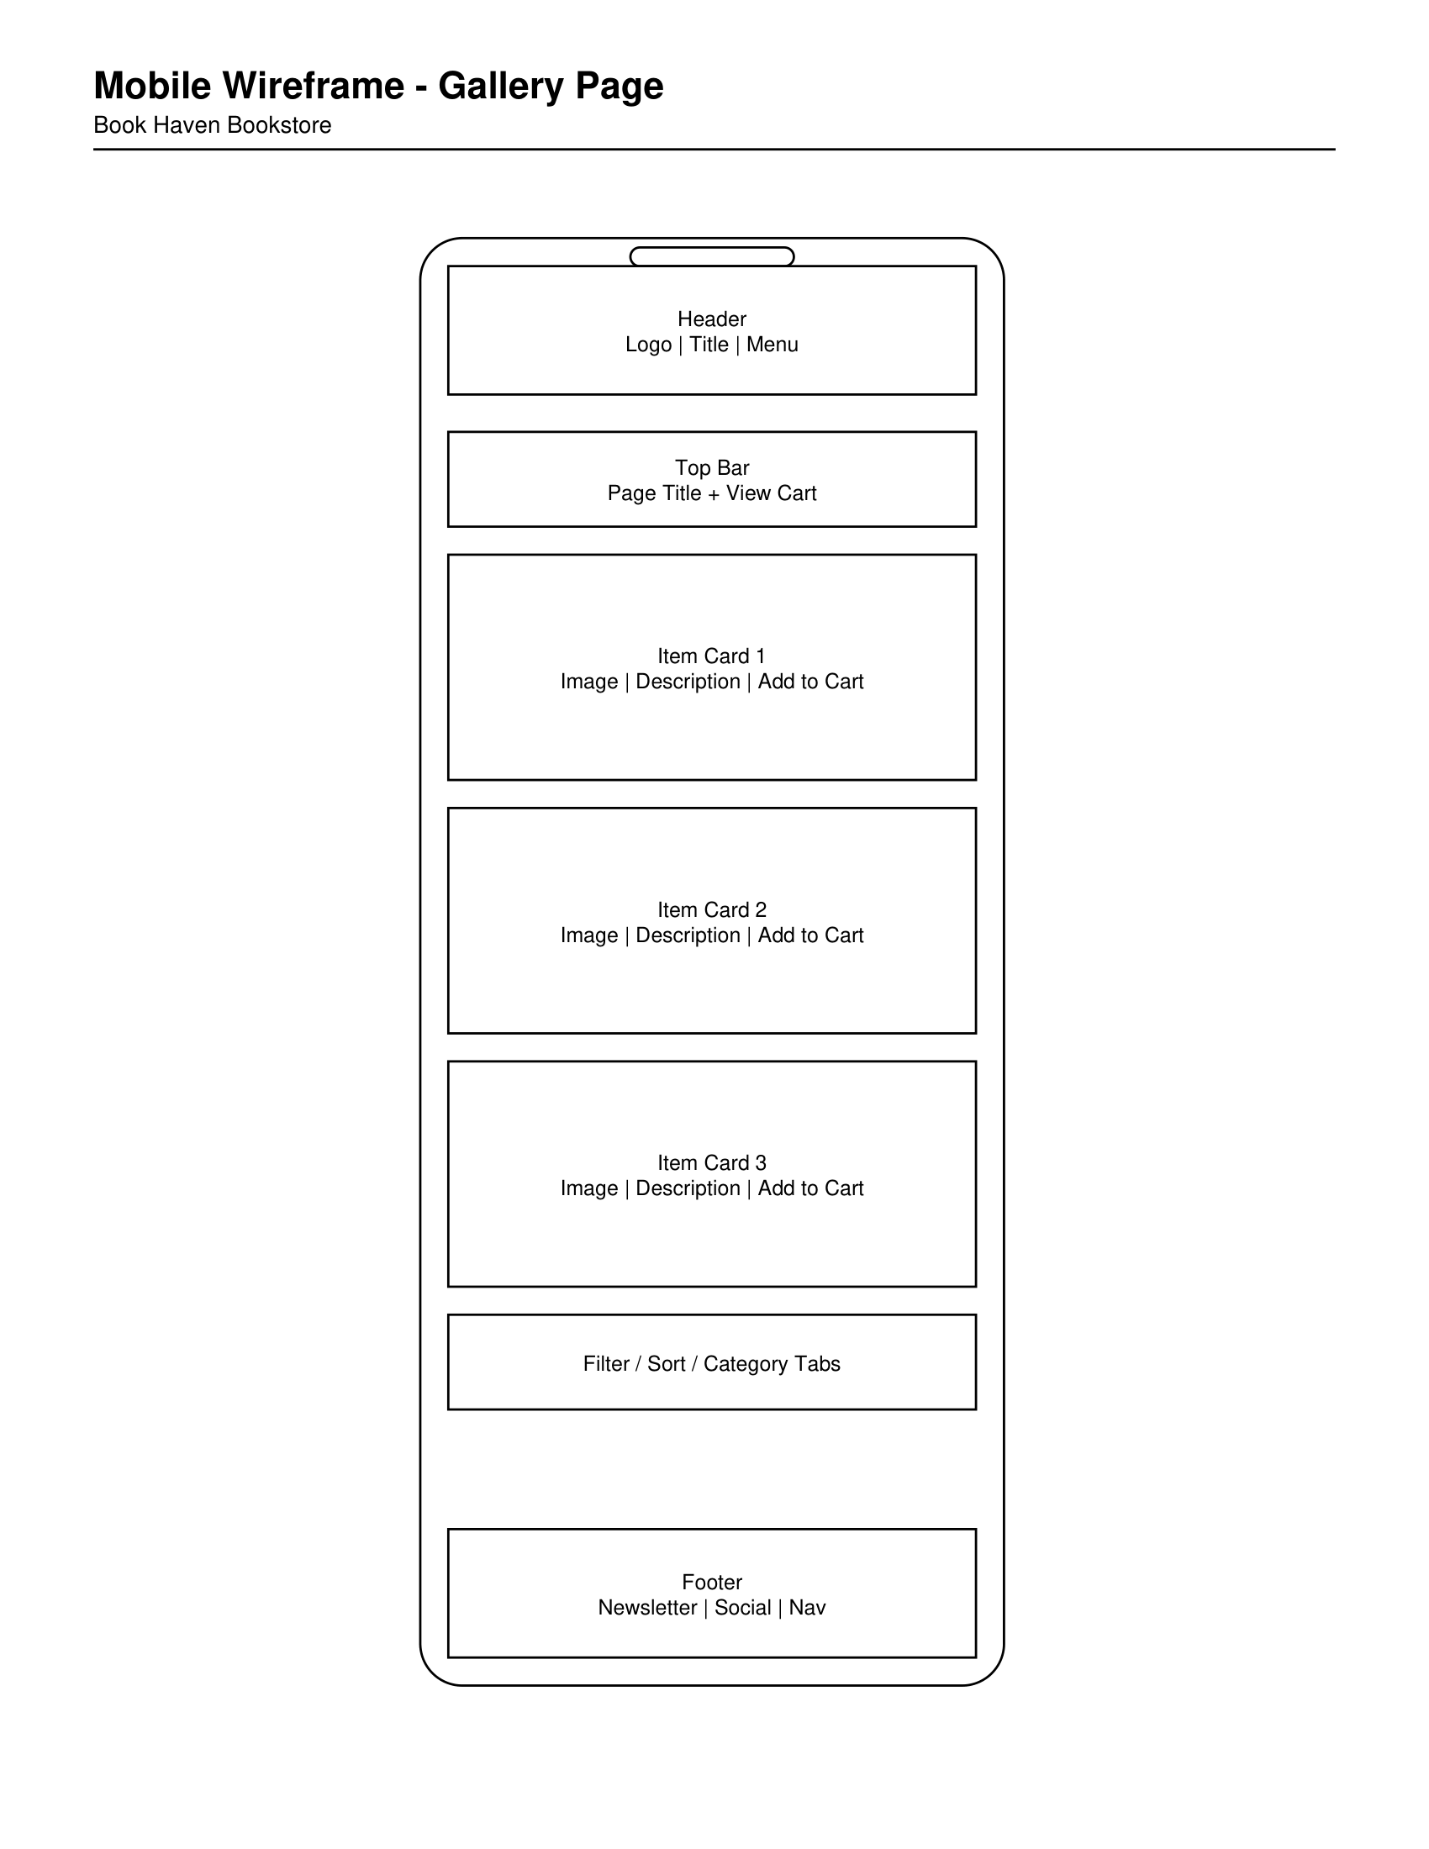
About Us Page
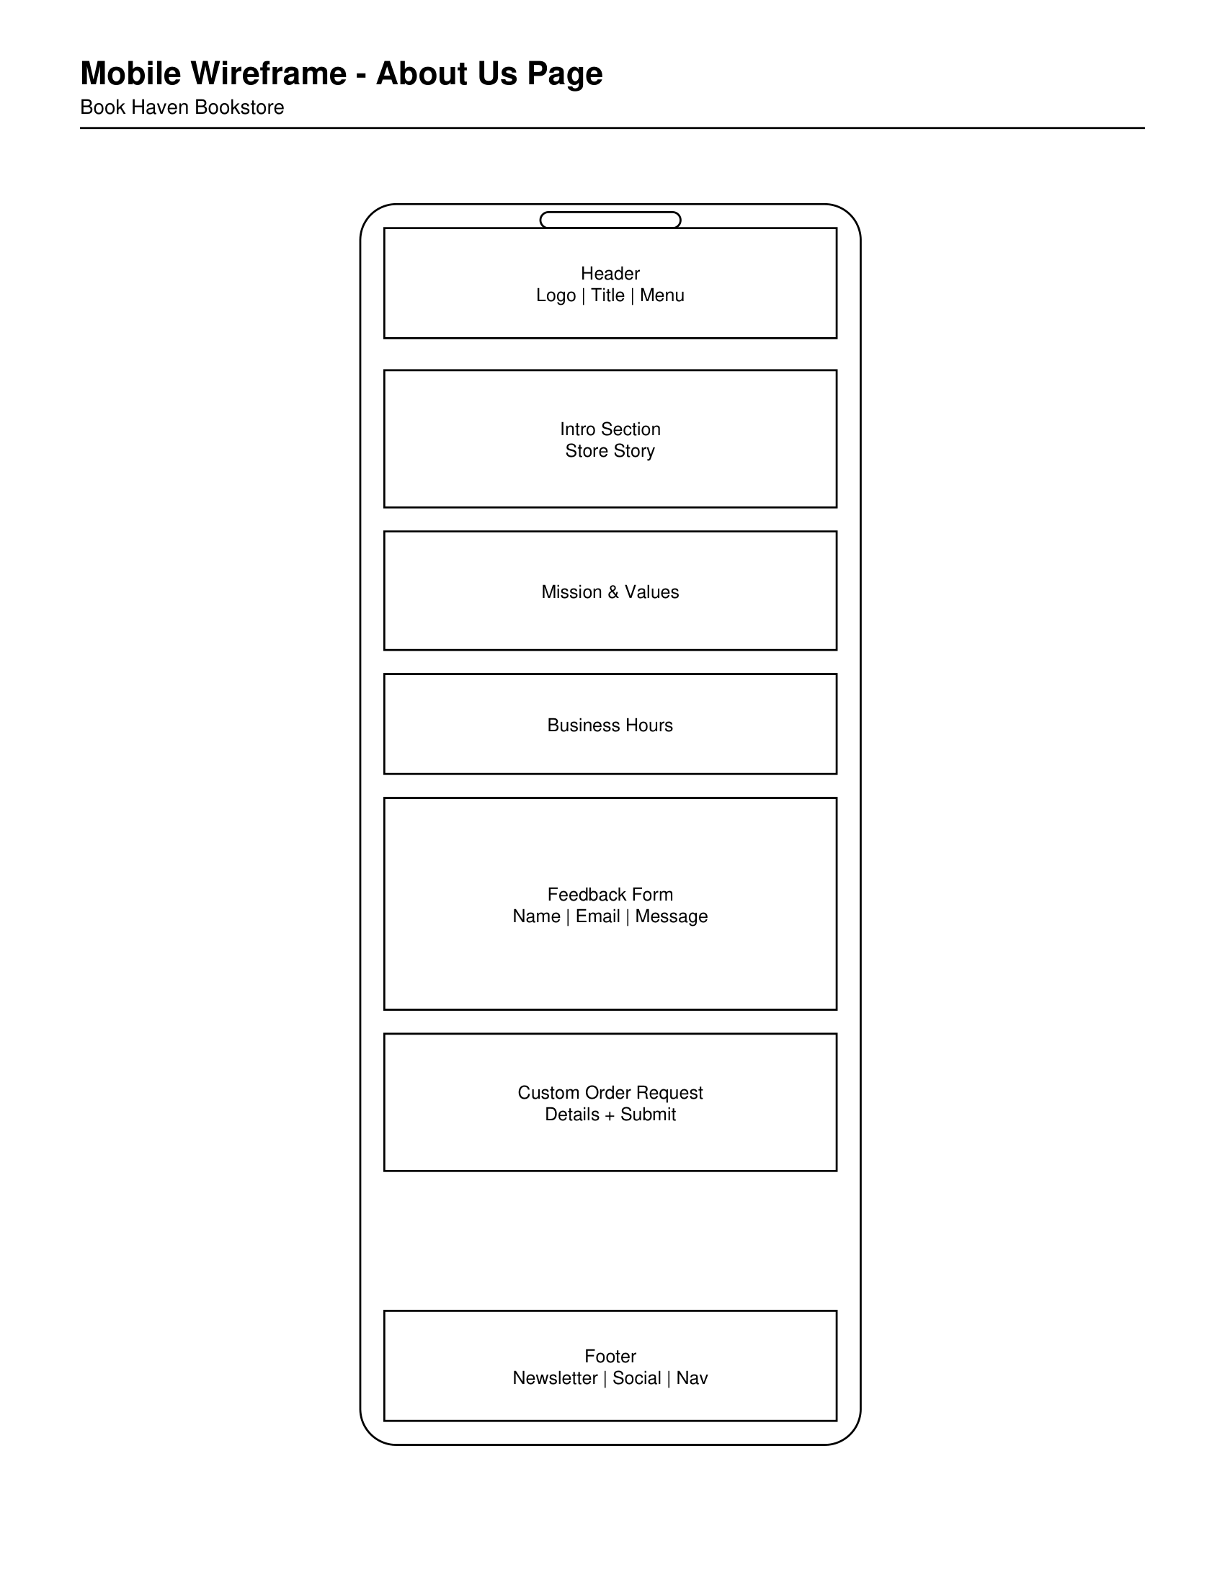
Events & Community Page (Custom)
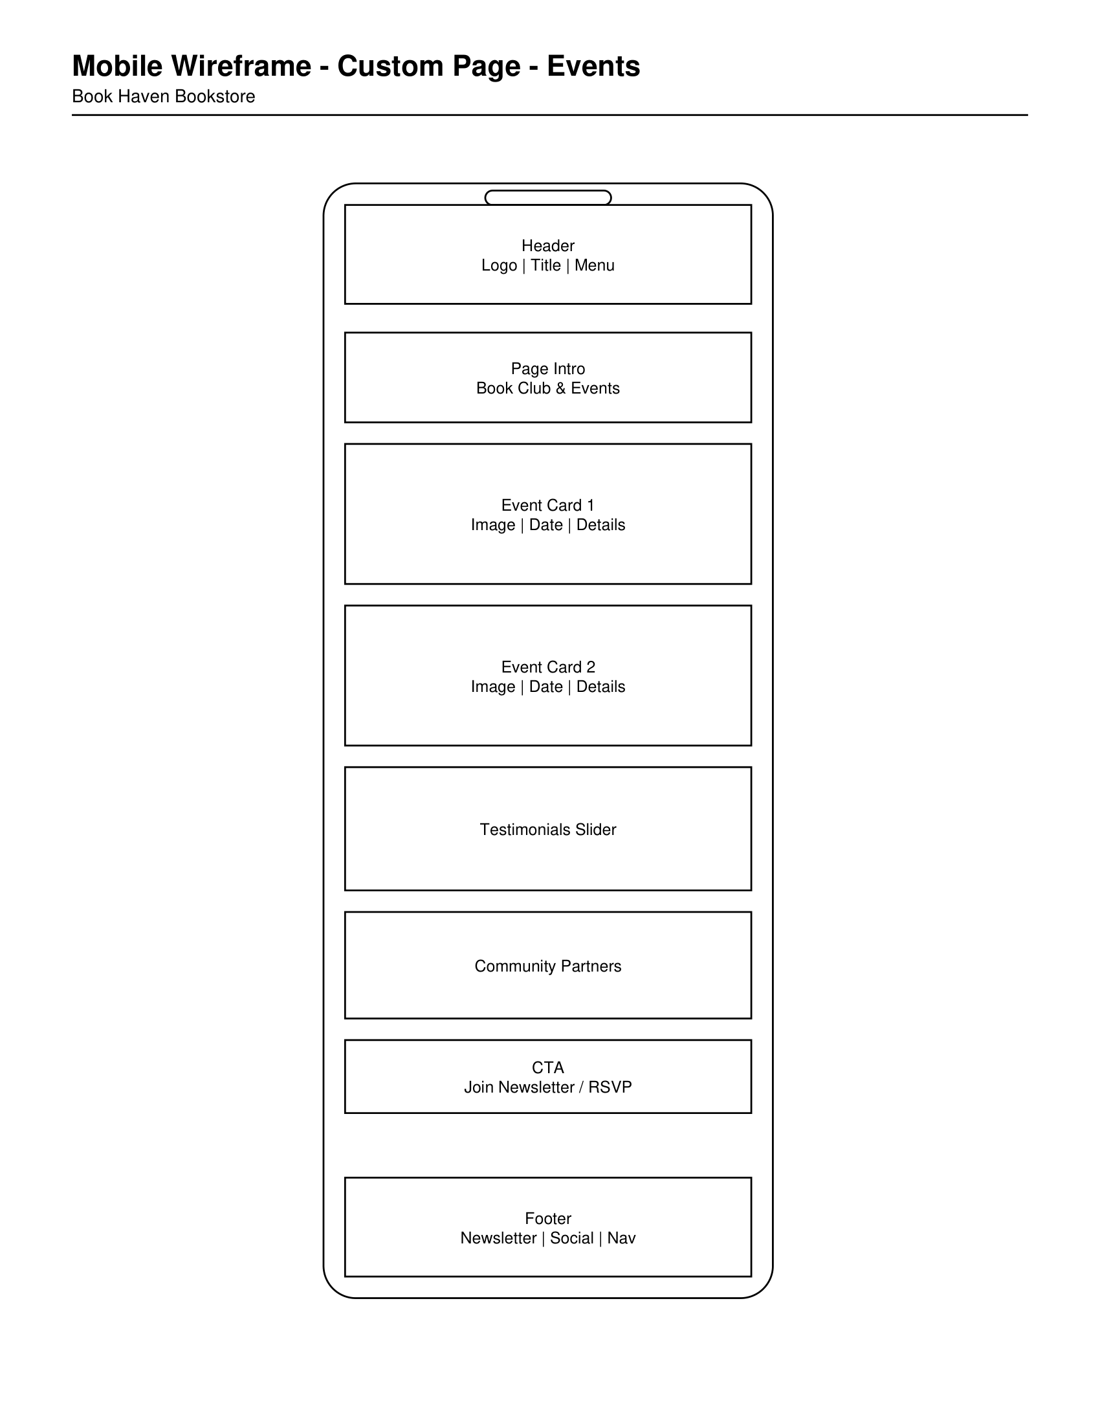
Desktop Wireframes
Homepage
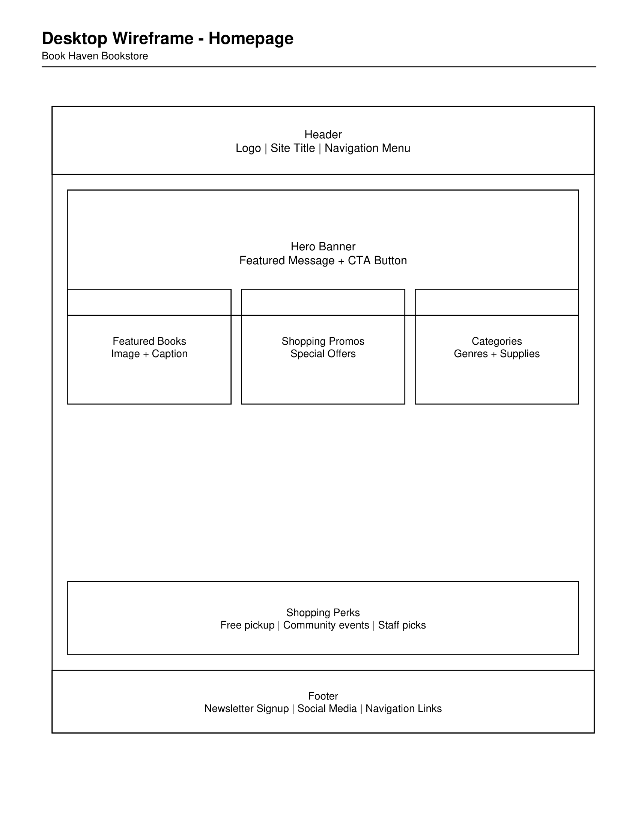
Gallery Page
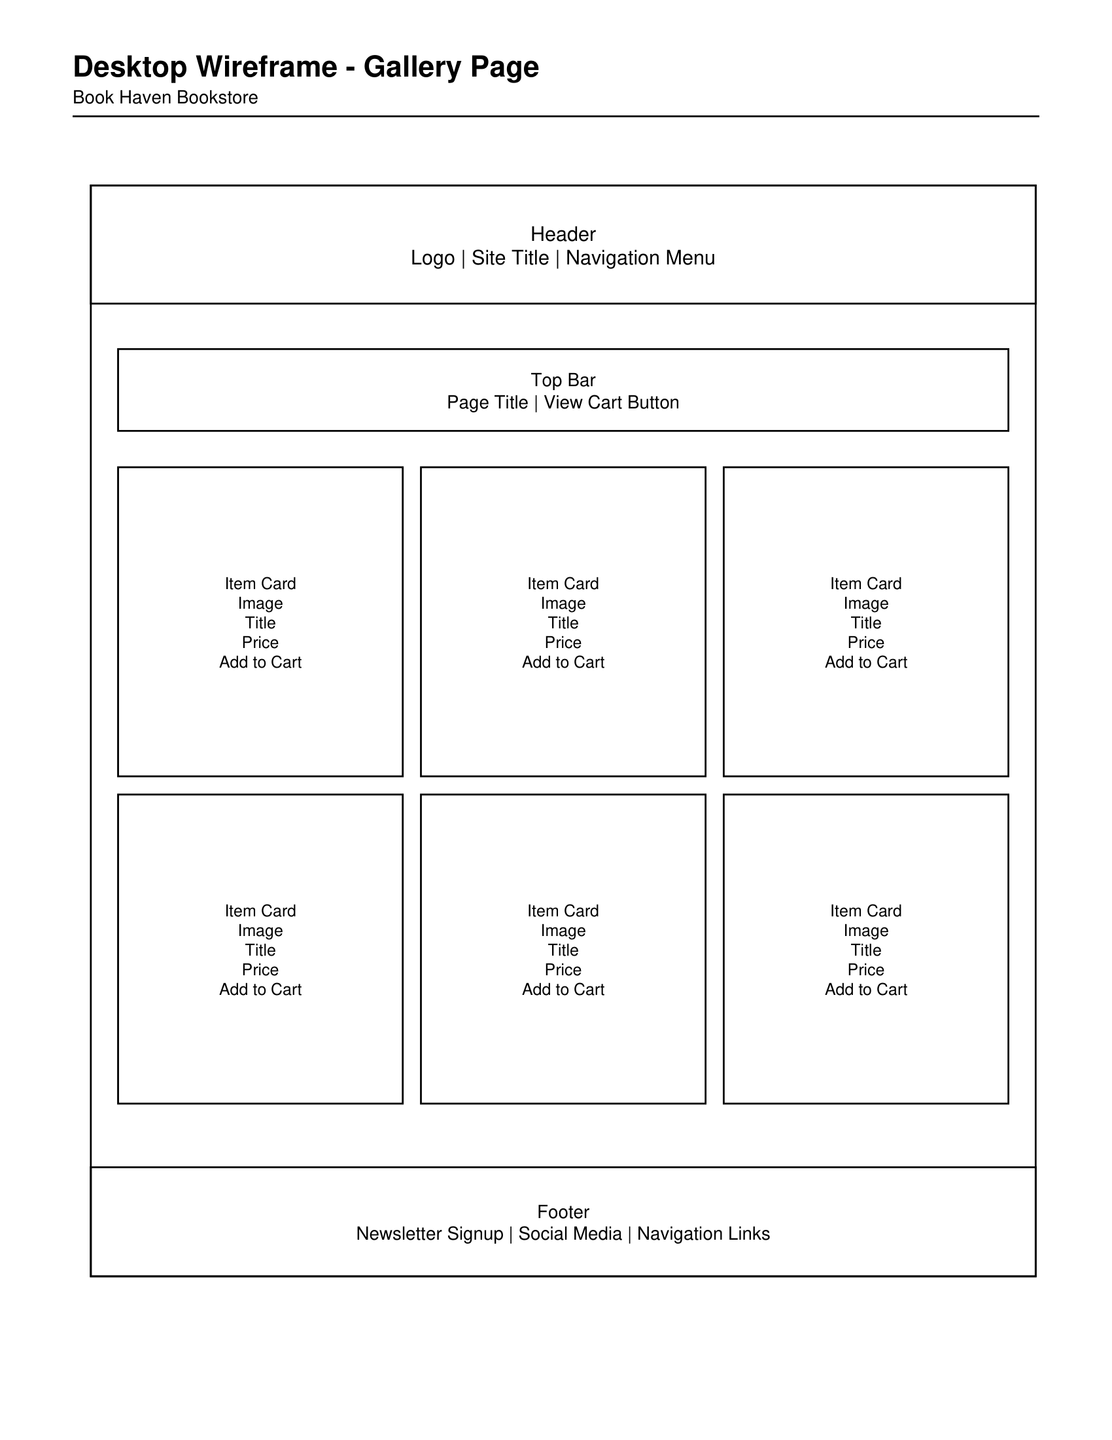
About Us Page
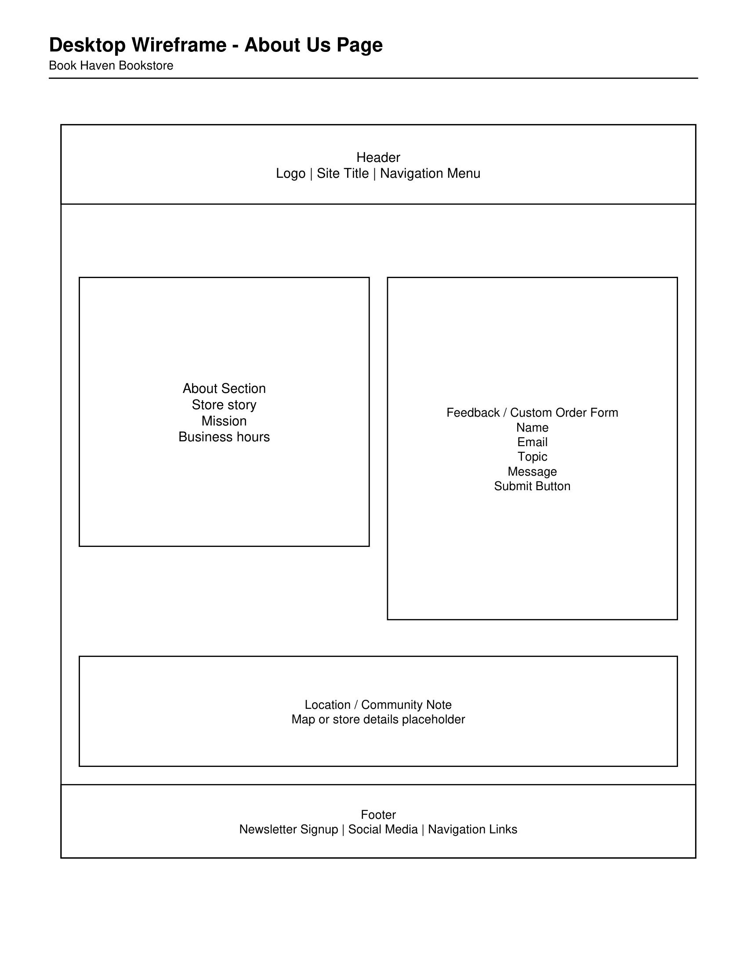
Events & Community Page (Custom)
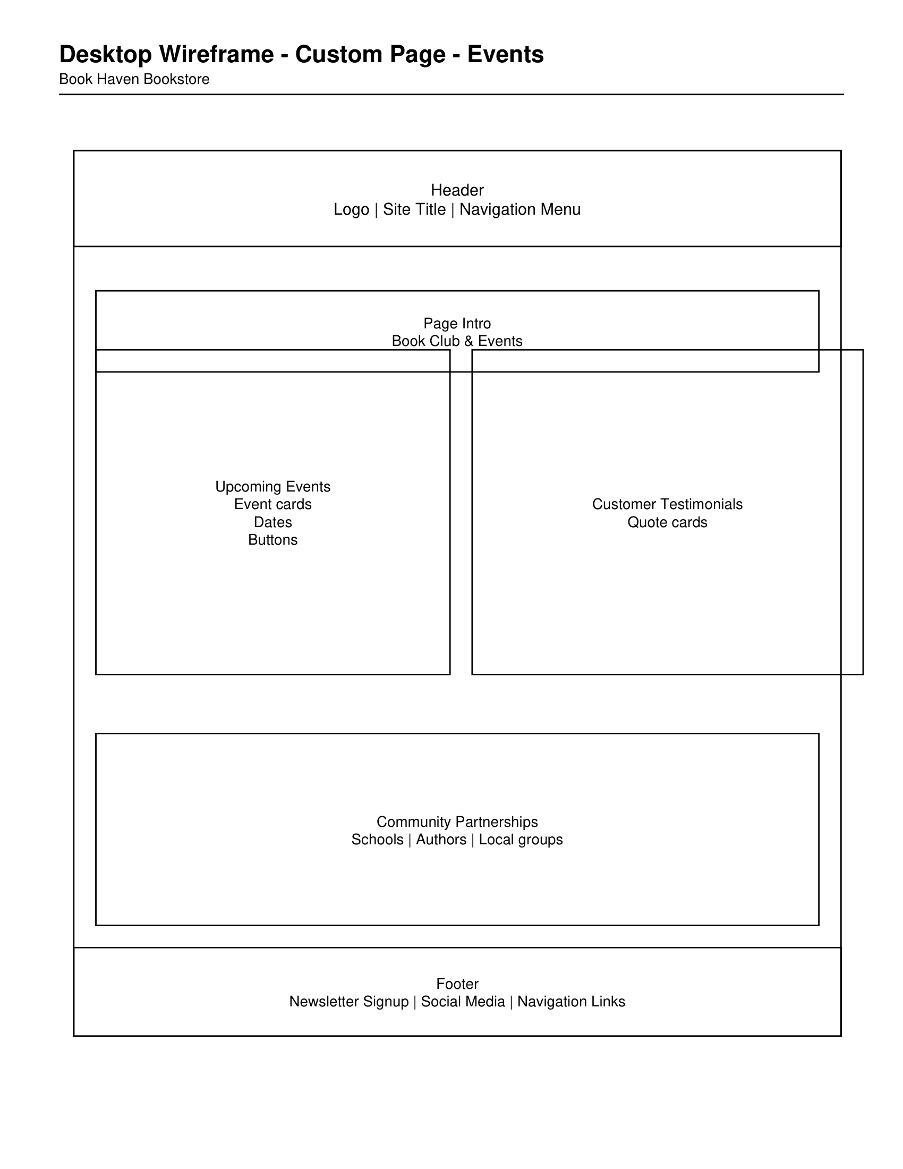
The custom page is an Events and Community page featuring book clubs, upcoming events, testimonials, and local partnerships. The mobile and desktop wireframes use consistent headers, footers, navigation, image placeholders, button placeholders, and labeled content sections.

Color Palette Selection
Hint: Which color palette did you choose for your selected client? Select a color palette from the choices in the Client Scenario and Criteria

- The color palette, logo, font color, and typefaces should be appropriate according to the client description provided in Client Scenario and Criteria.
- For the color palette, font color, and typefaces, provide the choice number of your selected option. If you plan to select colored font/text, you must include a color contrast report.
Color Palette 1
Color Palette Analysis
Hint: Why did you choose each color in the color palette, and how will it meet the needs of the client or the client’s desired theme and style?
I selected Color Palette 1 because it supports the welcoming and literary atmosphere that Book Haven Bookstore wants to create. Inkwell Blue and Aged Gold give the site an elegant, classic feel that fits a bookstore, while Parchment White keeps the layout clean and easy to read. Dusty Rose and Intensity Indigo work well as accent colors for promotions, buttons, and featured sections without overwhelming the page. Overall, the palette feels warm, polished, and inviting for readers, students, and community members.

Logo Selection
Hint: Which logo did you choose for your selected client? Select a logo from the choices in the Client Scenario and Criteria.

Logo 1
Logo Selection Analysis
Hint: Why did you choose the logo, and how will it meet the needs of the client or the client’s desired theme and style?
I chose Logo 1 because it gives the website a clear and professional visual identity while still feeling approachable. Its simple design works well with the bookstore theme and pairs naturally with the darker colors in the palette, especially Inkwell Blue. This choice helps the brand look organized, trustworthy, and memorable, which is important for a business that wants to build a strong literary community online.

Font Color Selection
Hint: Which of the provided font colors would you choose for your client’s website? Select a font color from the choices in the Client Scenario and Criteria.
Font Color 2 - Bookish Black (#131C26)
Font Color Analysis
Hint: Justify your choice of font color. If you include colors for the text on the site, make sure that you include a color contrast report such as https://accessibleweb.com/color-contrast-checker/ or https://webaim.org/resources/contrastchecker/ to ensure the font will meet accessibility needs.
I selected Bookish Black because it provides strong contrast against the lighter background colors and keeps the website highly readable. A near-black tone is easier on digital screens than pure black, but it still looks professional and clear for headings, navigation, product descriptions, and forms. I do not plan to use colored body text, so a separate color contrast report is not needed for this submission.

Typography Selection
Hint: Which of the provided typography would you choose for your client’s website? Select a set of typefaces from the provided typeface choices in the Client Scenario and Criteria.
Typography Option 2
Typography Analysis
Hint: Why did you choose these specific typefaces and font types?
I selected Typography Option 2 because it combines readability with a clean and modern appearance. Arial and Calibri are easy to read on screens and work well for navigation, body text, and product information, which is important for a content-rich bookstore website. Comfortaa adds a softer, more distinctive look for subtitles and featured sections without reducing legibility. Together, these typefaces create a clear visual hierarchy and support the welcoming, organized style the client wants.

